Project report on

“COVID-19 Real-Time Android App”

**Submitted by**

**Aditya Mishra**

**Meet Mewada**

**Om Dubey**

**Sarvesh Karangutkar**

**Project Guide**

**Ms. Smita Dandge**



**Department of Computer Engineering**

***ZAGDU SINGH CHARITABLE TRUST (REGD.)***

**THAKUR POLYTECHNIC**

**(**An ISO 9001:2015 Certified Institute**)**

Thakur Complex, West to W.E. Highway, Kandivli (E), Mumbai – 400 101.

**2020-2021**



**PROJECT APPROVAL SHEET**

Academic Year 2020-2021

This Project work entitled

“COVID-19 Real-Time Android App”

By

**Aditya Mishra**

**Meet Mewada**

**Om Dubey**

**Sarvesh Karangutkar**

Is approved for the award of the

**DIPLOMA**

**IN**

**COMPUTER ENGINEERING**

Ms. Smita Dandge

**PROJECT GUIDE/MENTOR**

--------------------------------- ---------------------------------

**EXTERNAL EXAMINER**  **INTERNAL EXAMINER**



**Affiliated to Maharashtra State Board of Technical Education (MSBTE) Mumbai**

**C E R T I F I C A T E**

This is to certify that

**Mr.** **Aditya Mishra – Enrollment No : 1705220547**

**Mr. Meet Mewada – Enrollment No : 1805220493**

**Mr. Om Dubey – Enrollment No : 1805220492**

**Mr. Sarvesh Karangutkar – Enrollment No : 1805220508**

from **0522, Thakur Polytechnic** Institute have completed project of final year having title **COVID-19 Real-Time Android App** during the academic year 2020-2021. The project completed by individually/ in a group consisting of **Four** persons under the guidance of the Faculty Guide.

**………………………………...**

**Name and Signature of Guide**

**Ms. Smita Dandge**

**Telephone :……………………………..**

----------------------- ------------------------

**H.O.D. (CO) PRINCIPAL**

(Ms. VAISHALI RANE ) (Dr. S.M.GANECHARI)

**2020-2021**

Project report on

“COVID-19 Real-Time Android App”

**Submitted by**

**Aditya Mishra**

**Meet Mewada**

**Om Dubey**

**Sarvesh Karangutkar**

**Project Guide**

**Ms. Smita Dandge**



**Department of Computer Engineering**

Zagdu Singh Charitable Trust’s

**Thakur Polytechnic**

**(An ISO 9001 : 2015 Certified Institute)**

**Thakur Complex, Kandivali (East), Mumbai 400 101**

**2020-2021**

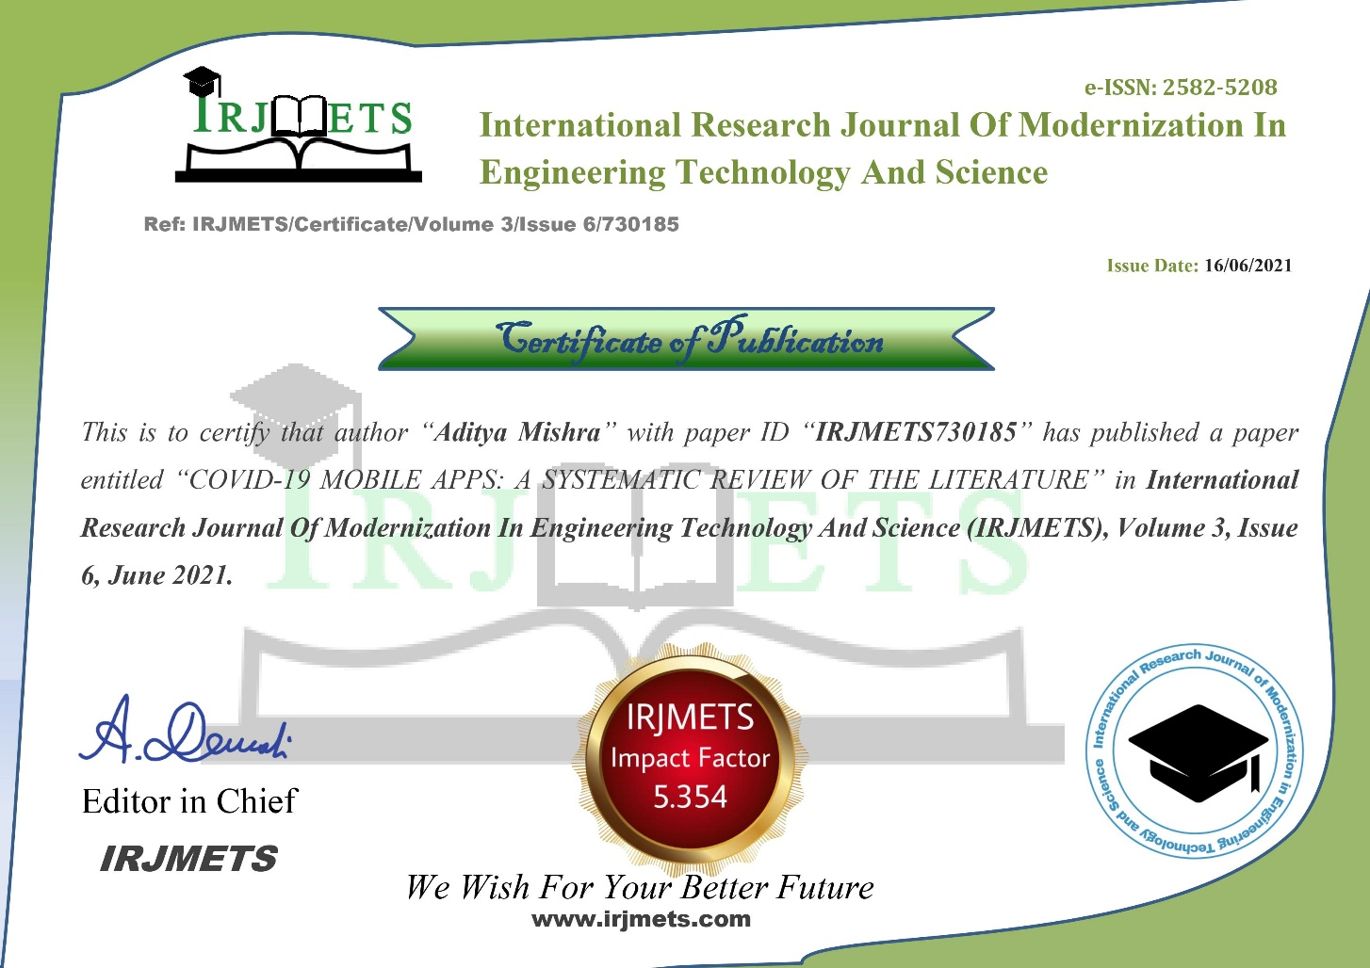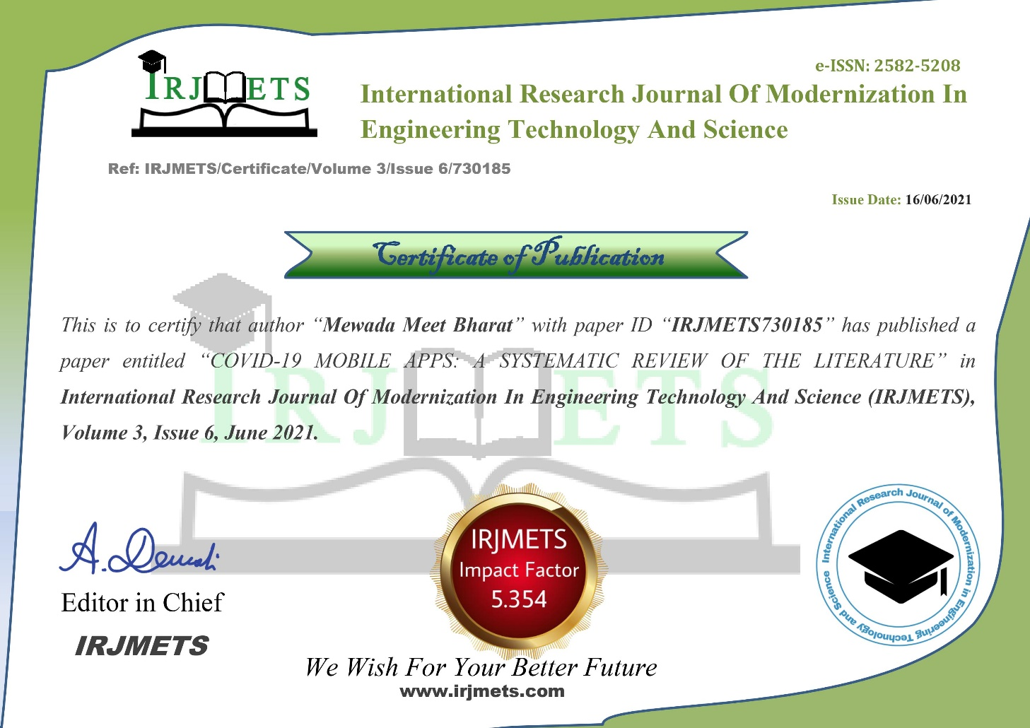

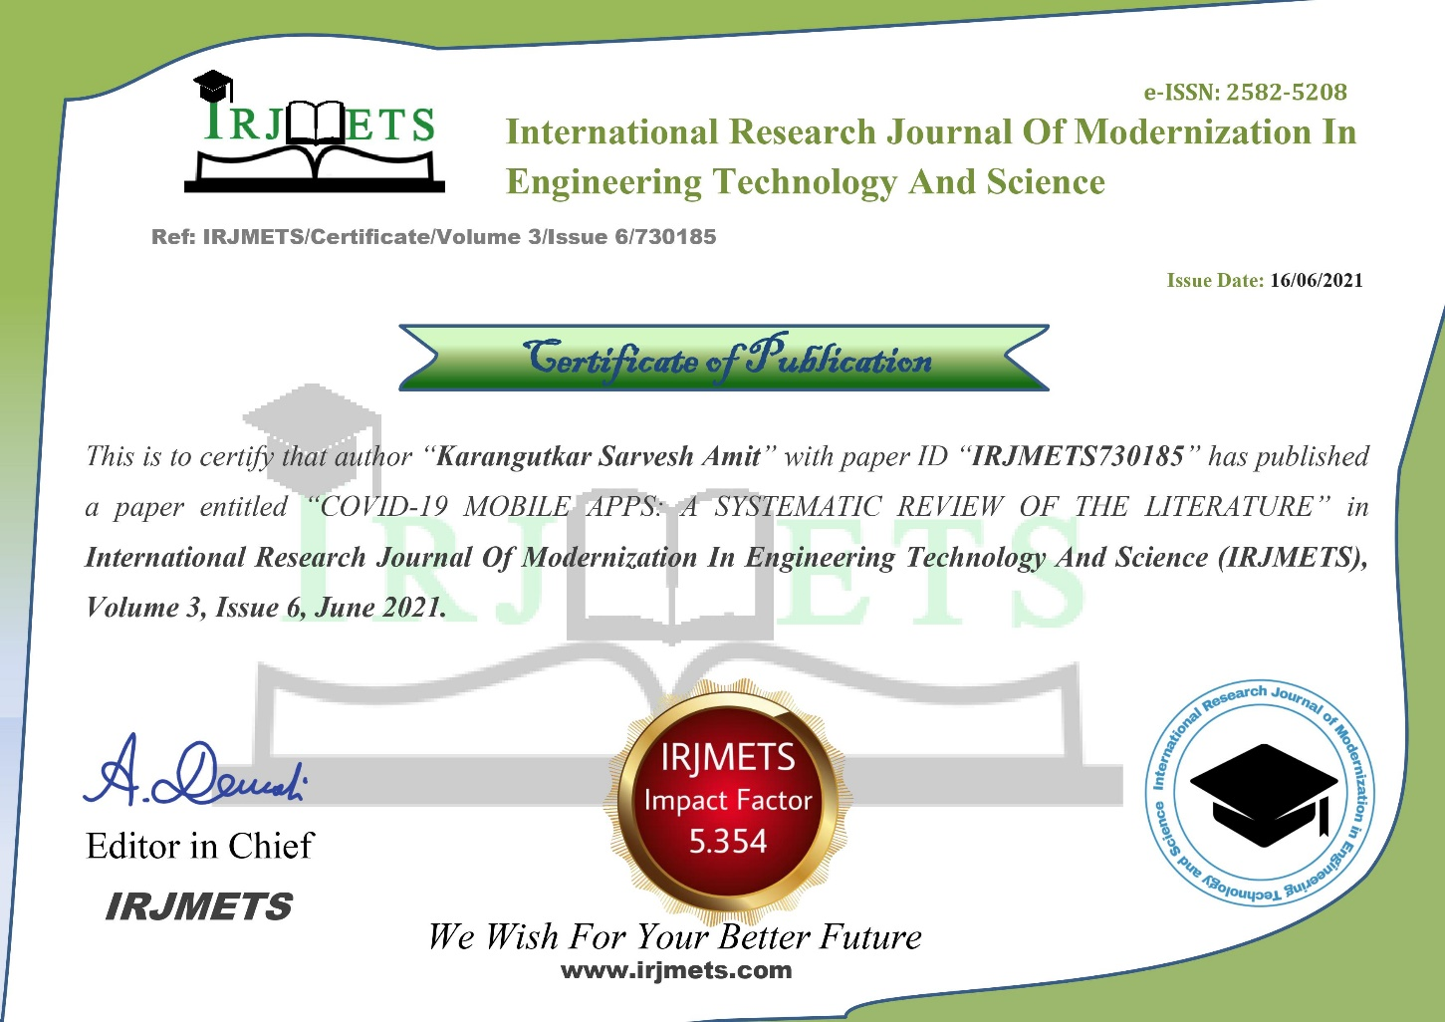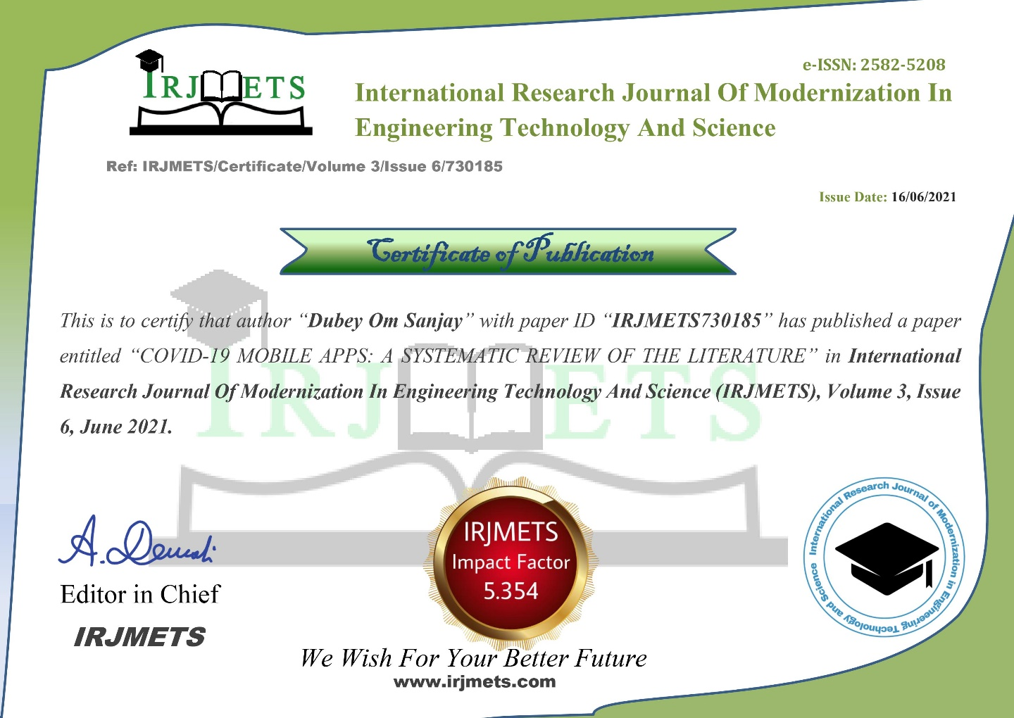

**ACKNOWLEDGEMENT**

As a part of third year syllabus, we could successfully complete our project **“COVID-19 Real-Time Android App”**. We feel immense pleasure in submitting the report, while submitting this report we avail this opportunity to express our gratitude toward all those who have guided and helped us in completing this task successfully. Heading the list is our honorable Principal **Dr. S.M. Ganechari** who is beginner of our inspiration. We would like to thank our H.O. D of computer engineering **Mrs. Vaishali Rane** for ardour in inciting the subject and her valuable suggestion. We owe deep gratitude to our guide **Mr. Manish Salvi** who proved to be supportive guide to us. Apart from bringing to us what can be joy for creative, every time he acted promptly to correct our mistakes. The successful completion of this project is possible by his guidance and co-operation only, without which the work would have never been completed. We give our whole hearted thank to our college **Thakur Polytechnic** for giving us the opportunity & support to the project. Finally, we wish to express our deep sense of respect and gratitude to our parents who always bear with us in any critical condition and to all others, for sparing their time and helping us for completion of this project in whatever way they could.

Sincere thanks to all group members.

**Name of Members**

Aditya Mishra – 04

Meet Mewada – 83

Om Dubey – 82

Sarvesh Karangutkar - 98